**Screenshots**

1. **Home page:**

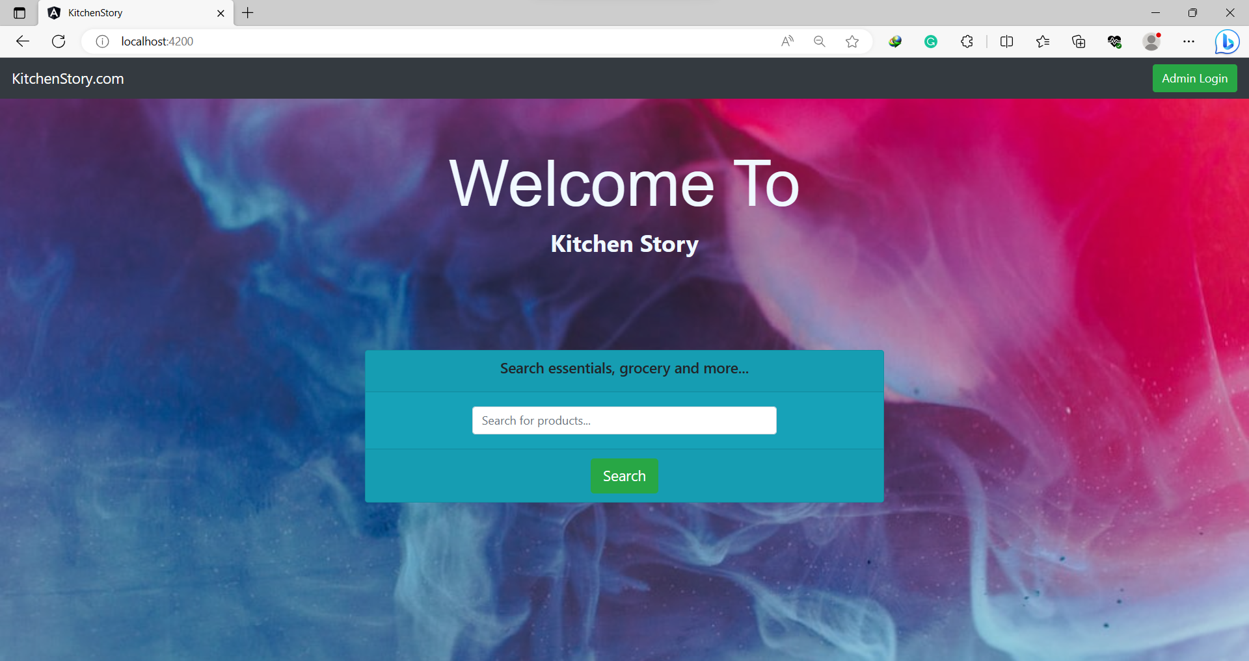

1. **Searching the products:**

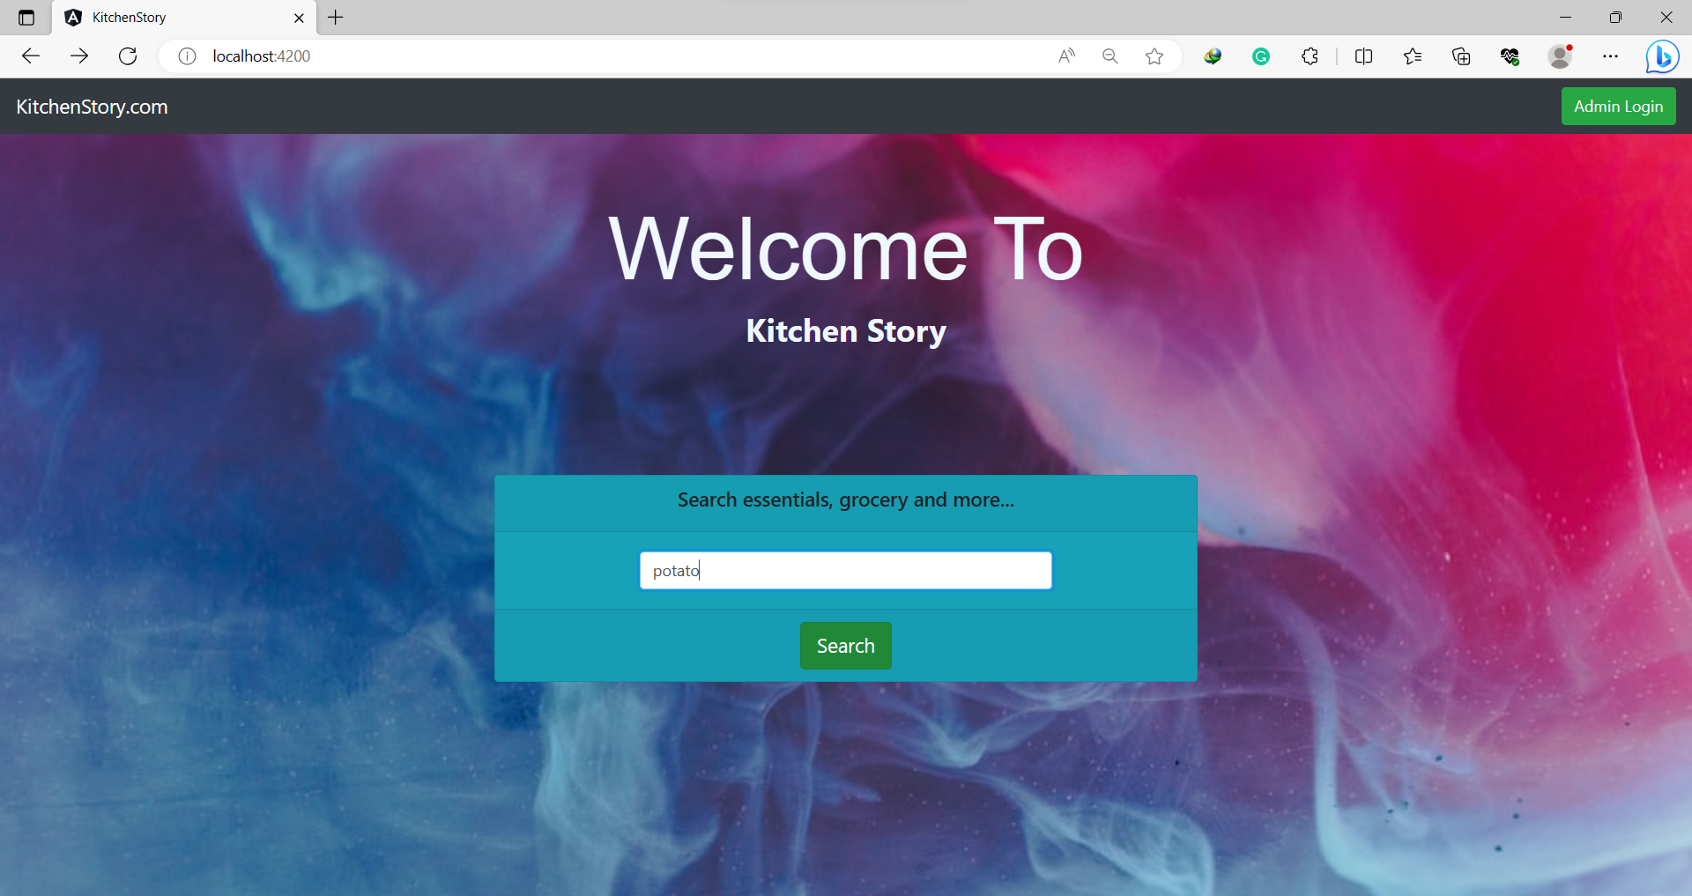

**3. Result:**

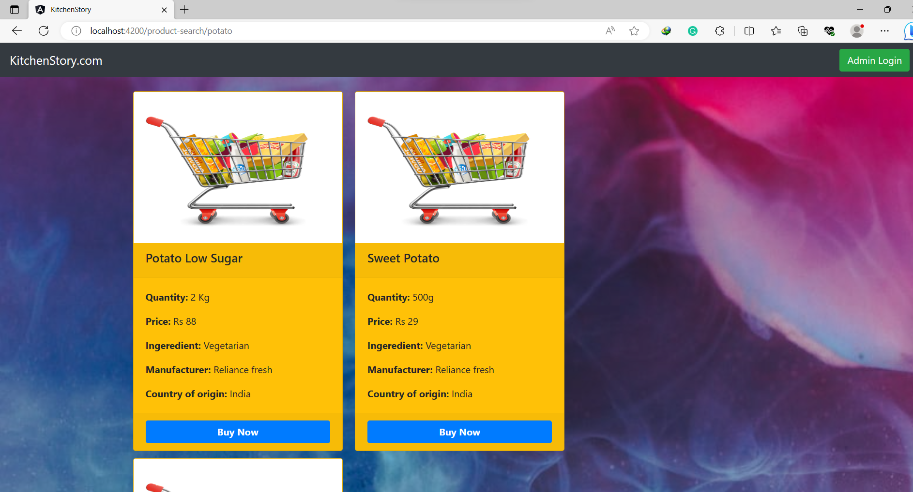

**After Clicking Buy Now Option**

**4. Placing Order by filling the details**

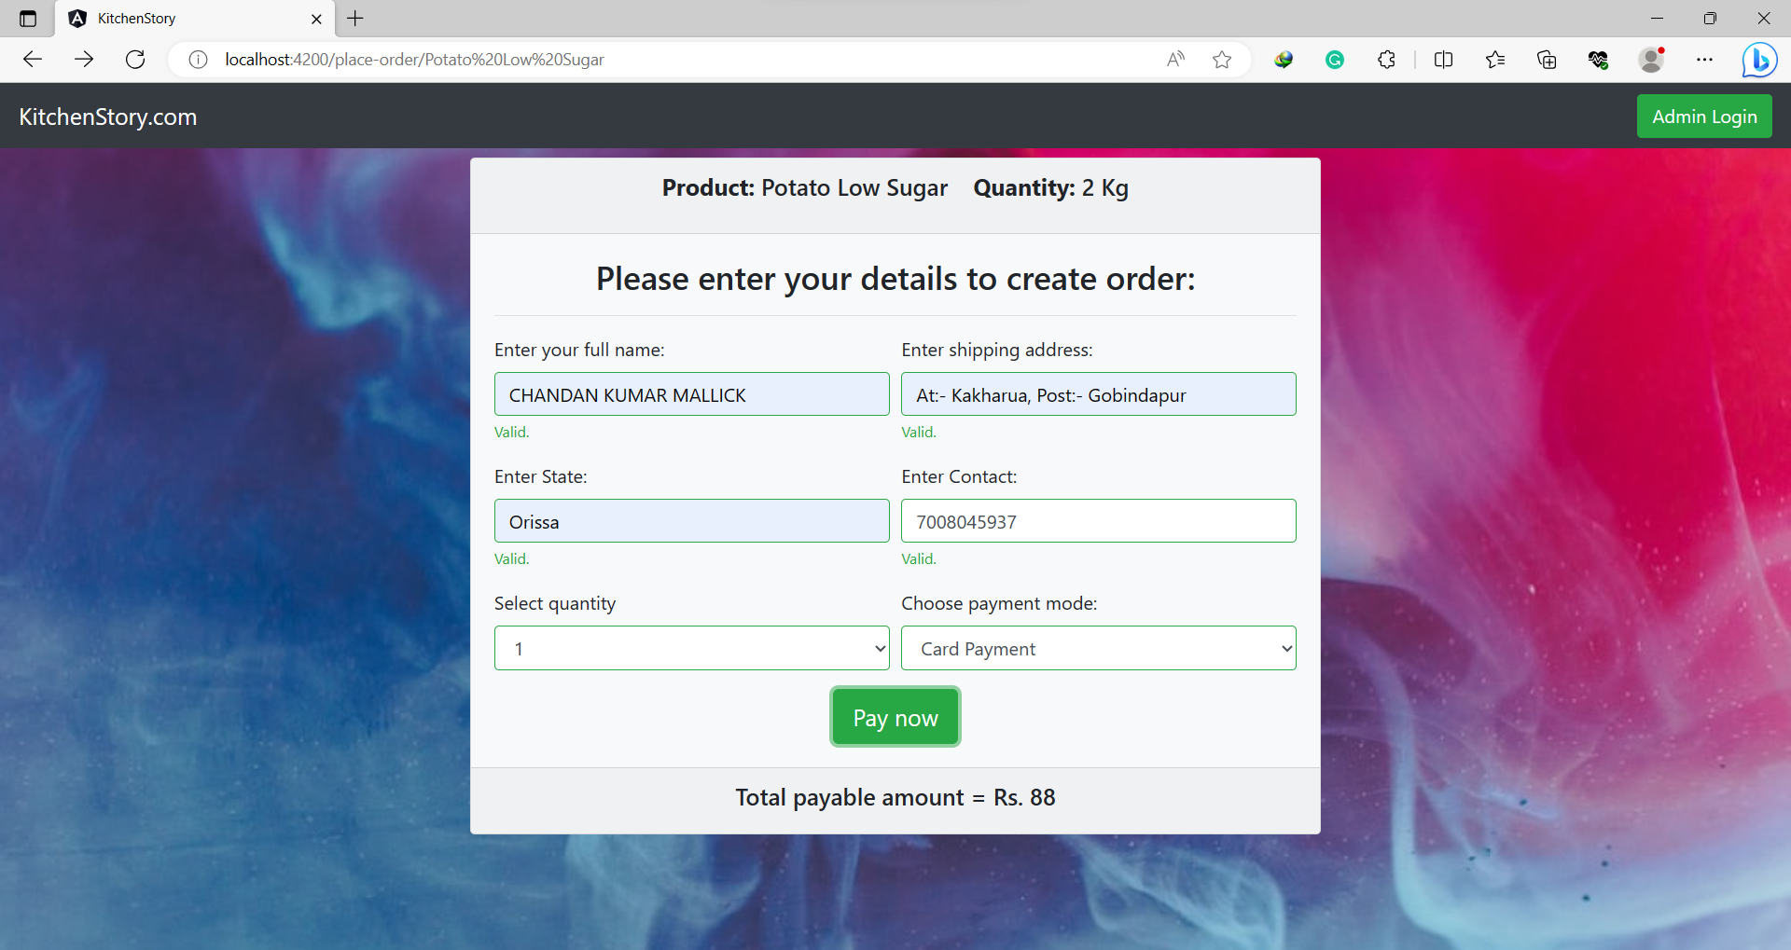

**5. Entering your card details**

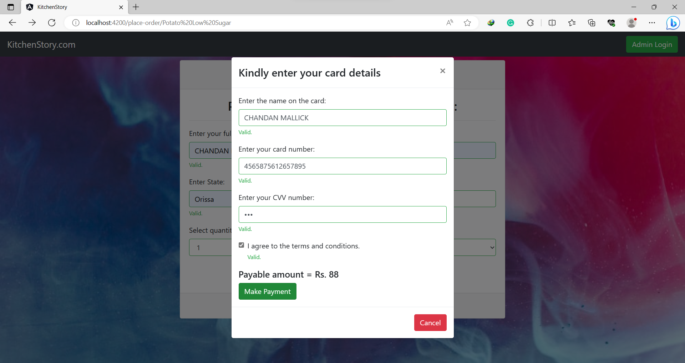

**6. Order Confirmation Page after making payment done.**

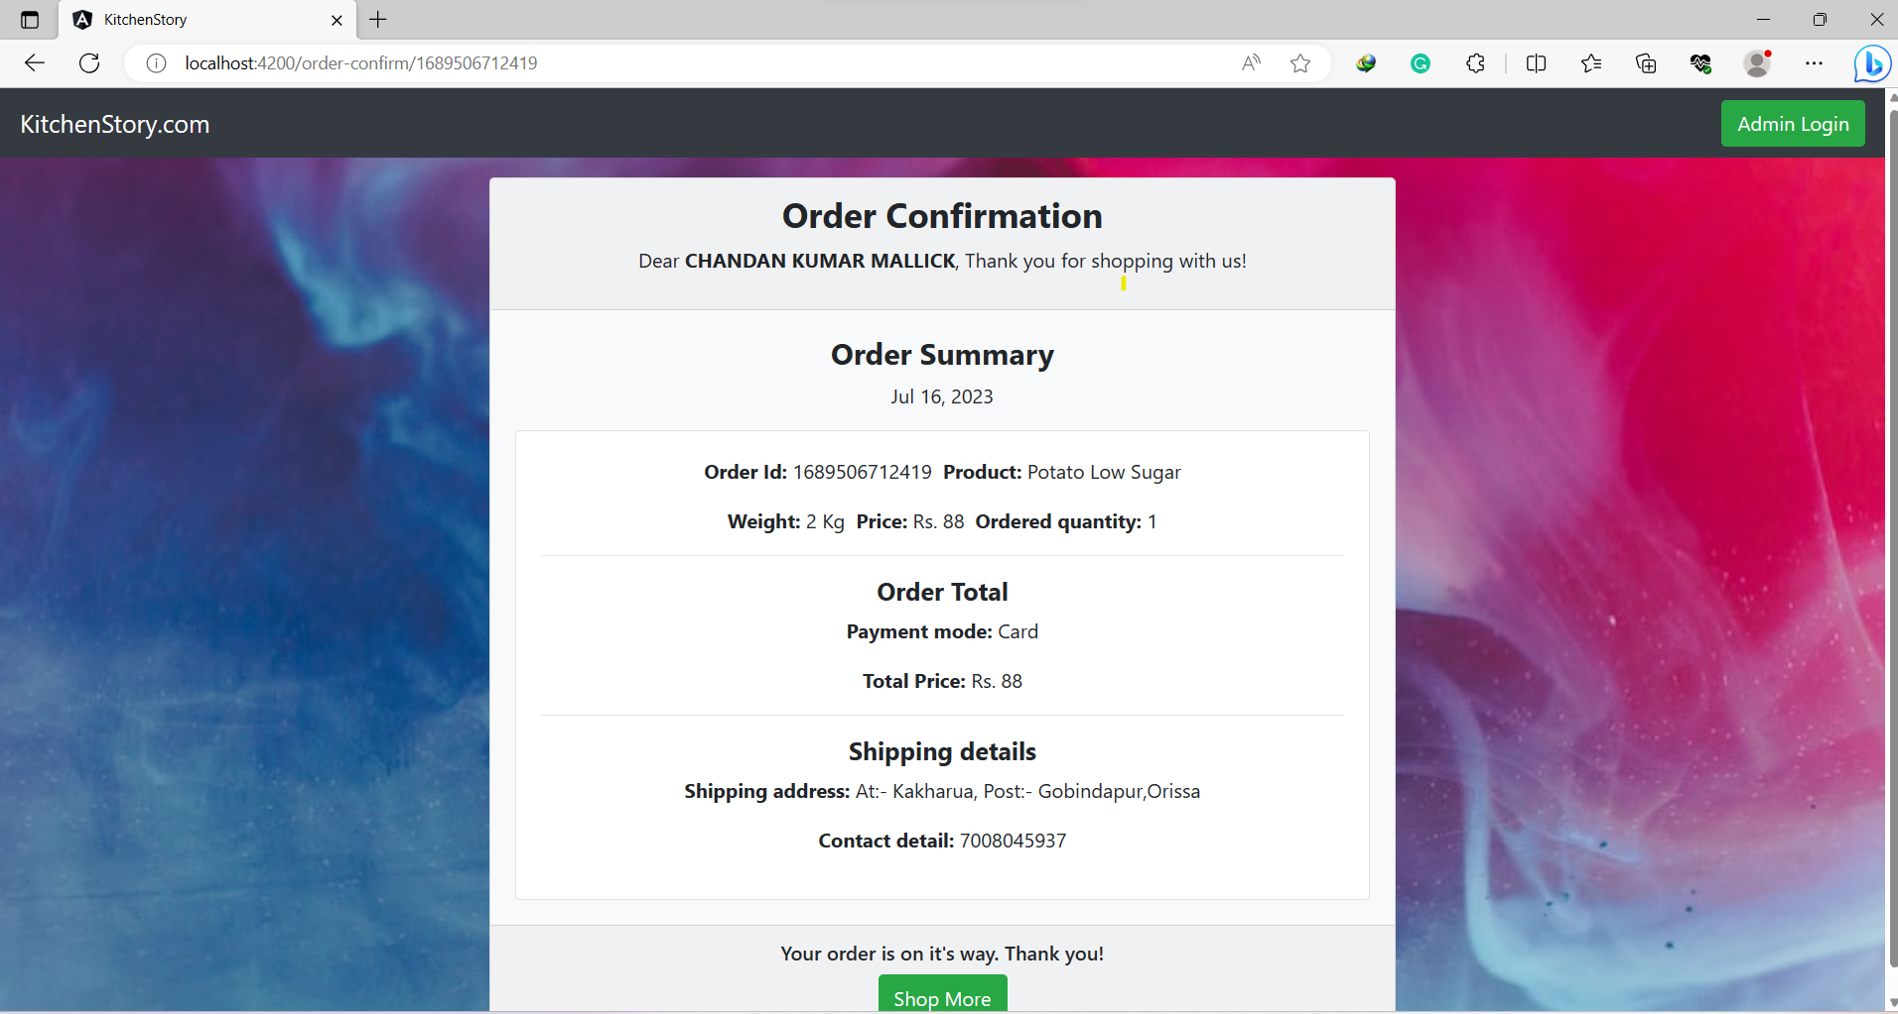

**To shop more click on Shop more Option**

**Click on Admin Login option to go into admin-login page**

**6. Admin Login Page**

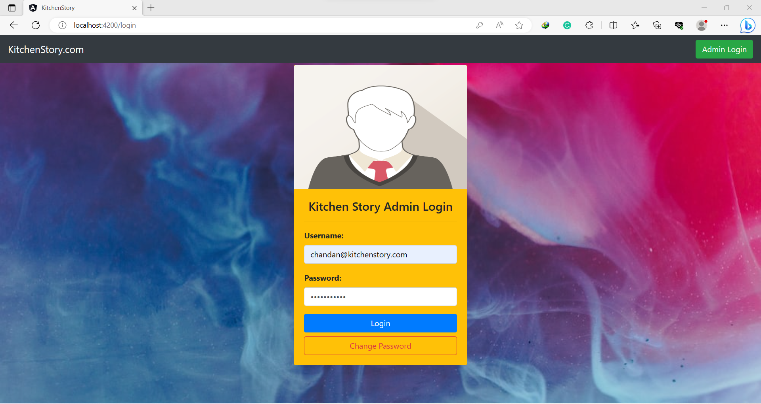

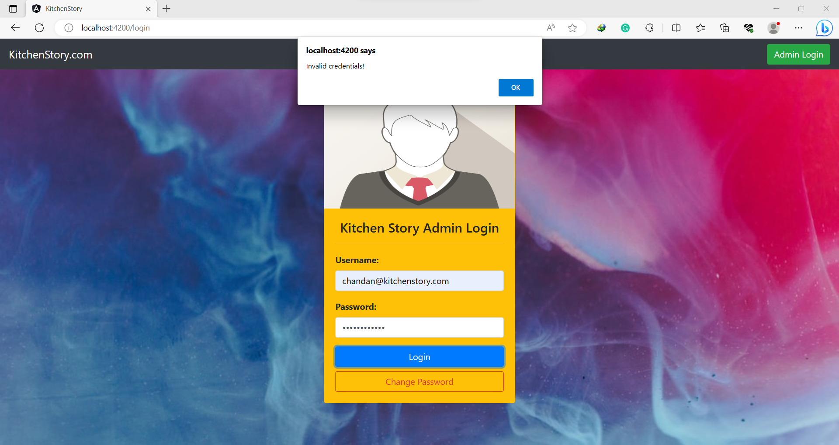**6. If you forgot your password then you can change password**

**7. Change password Page**

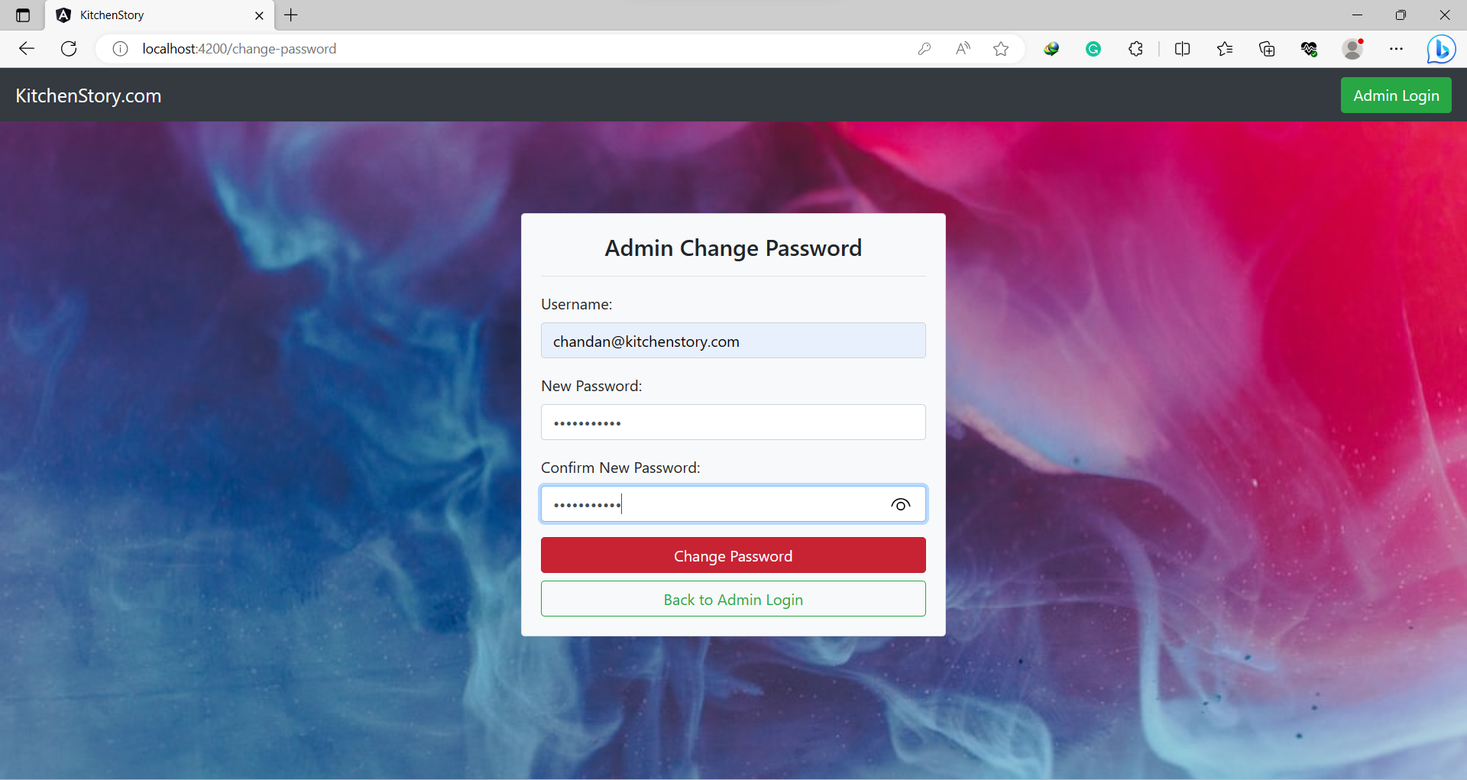

**8. Changing password successful Page**

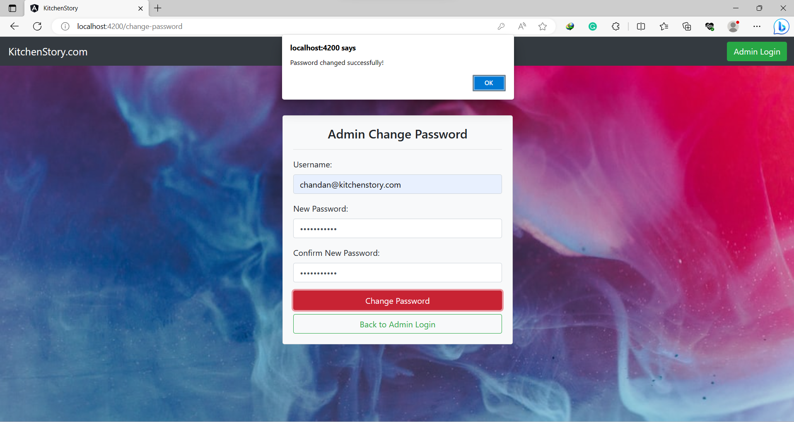

**9. Enter Correct Username & Password**



**10. Admin Dashboard Page**

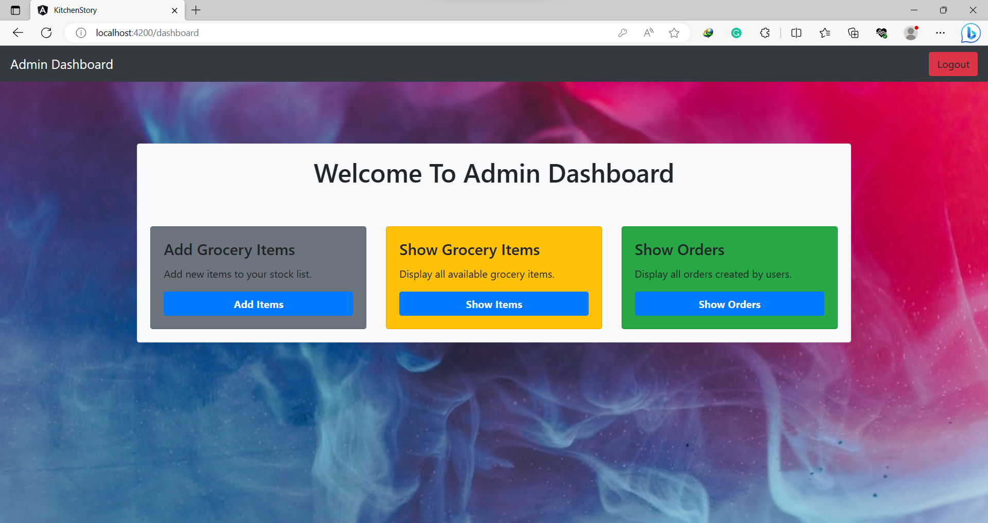

**11. Add Item Details:**

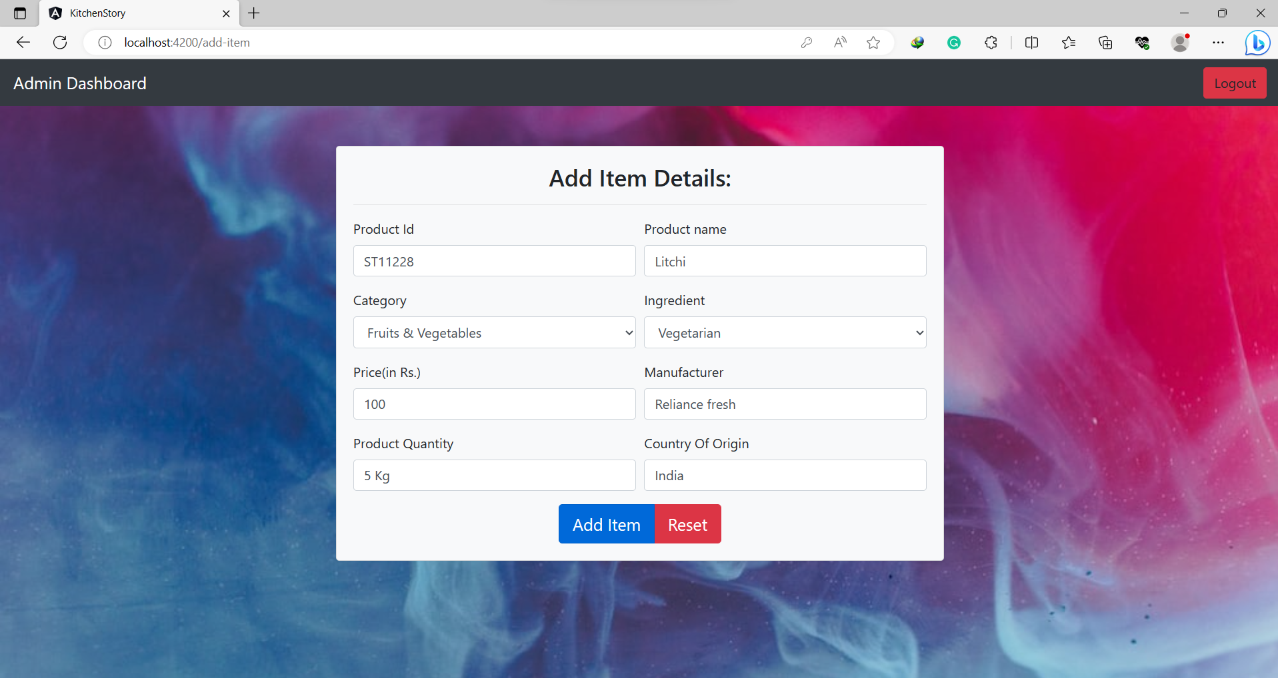

**12. Item Added Successfully!**

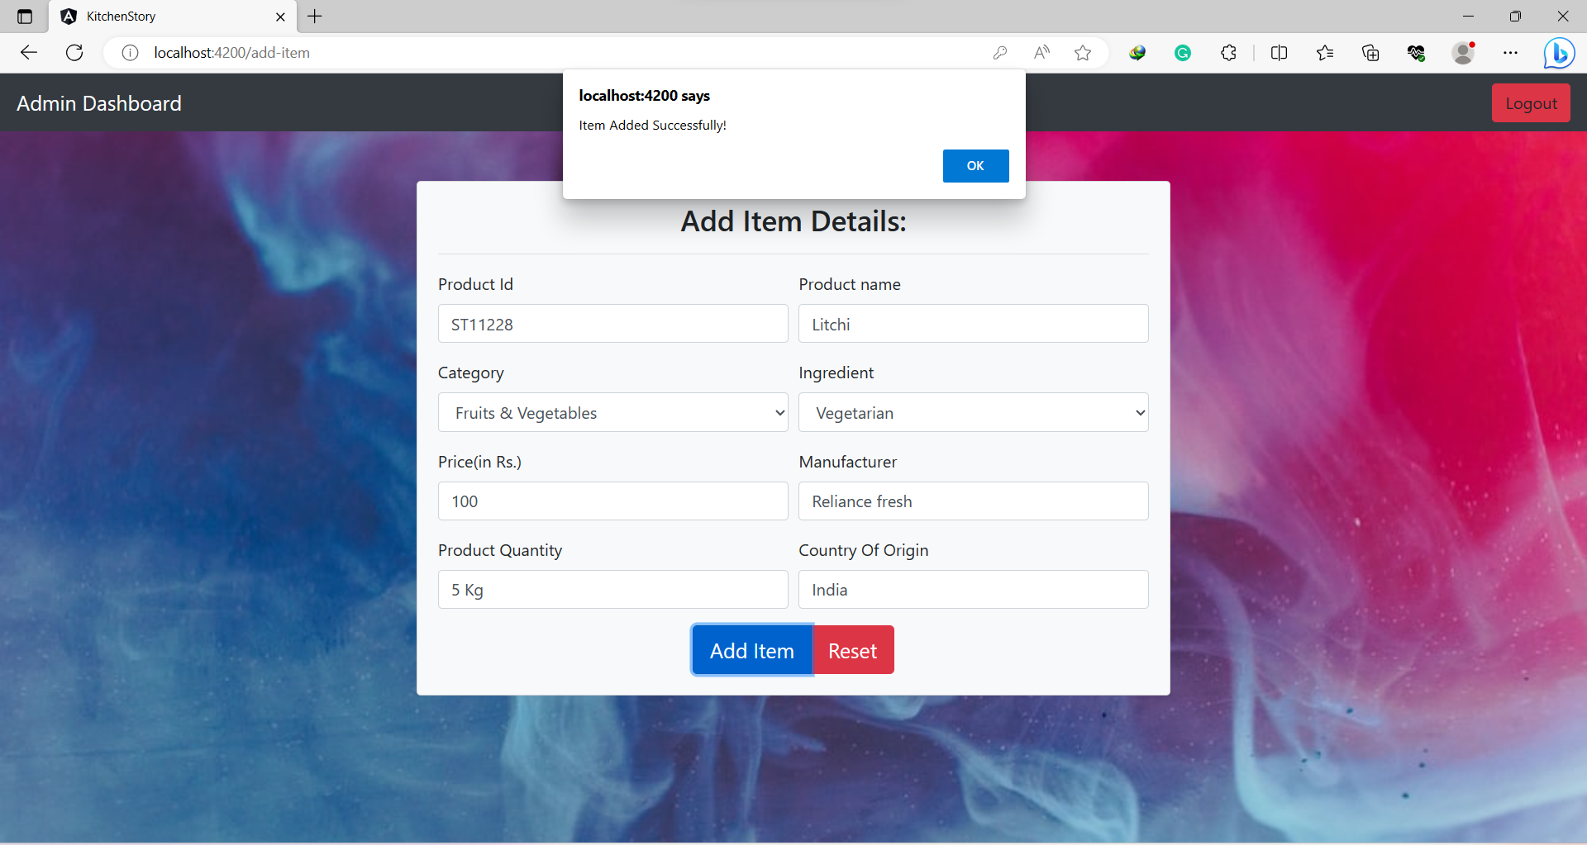

**Then Back to Admin Dashboard & click on show item option**.

**13. All Items Page**

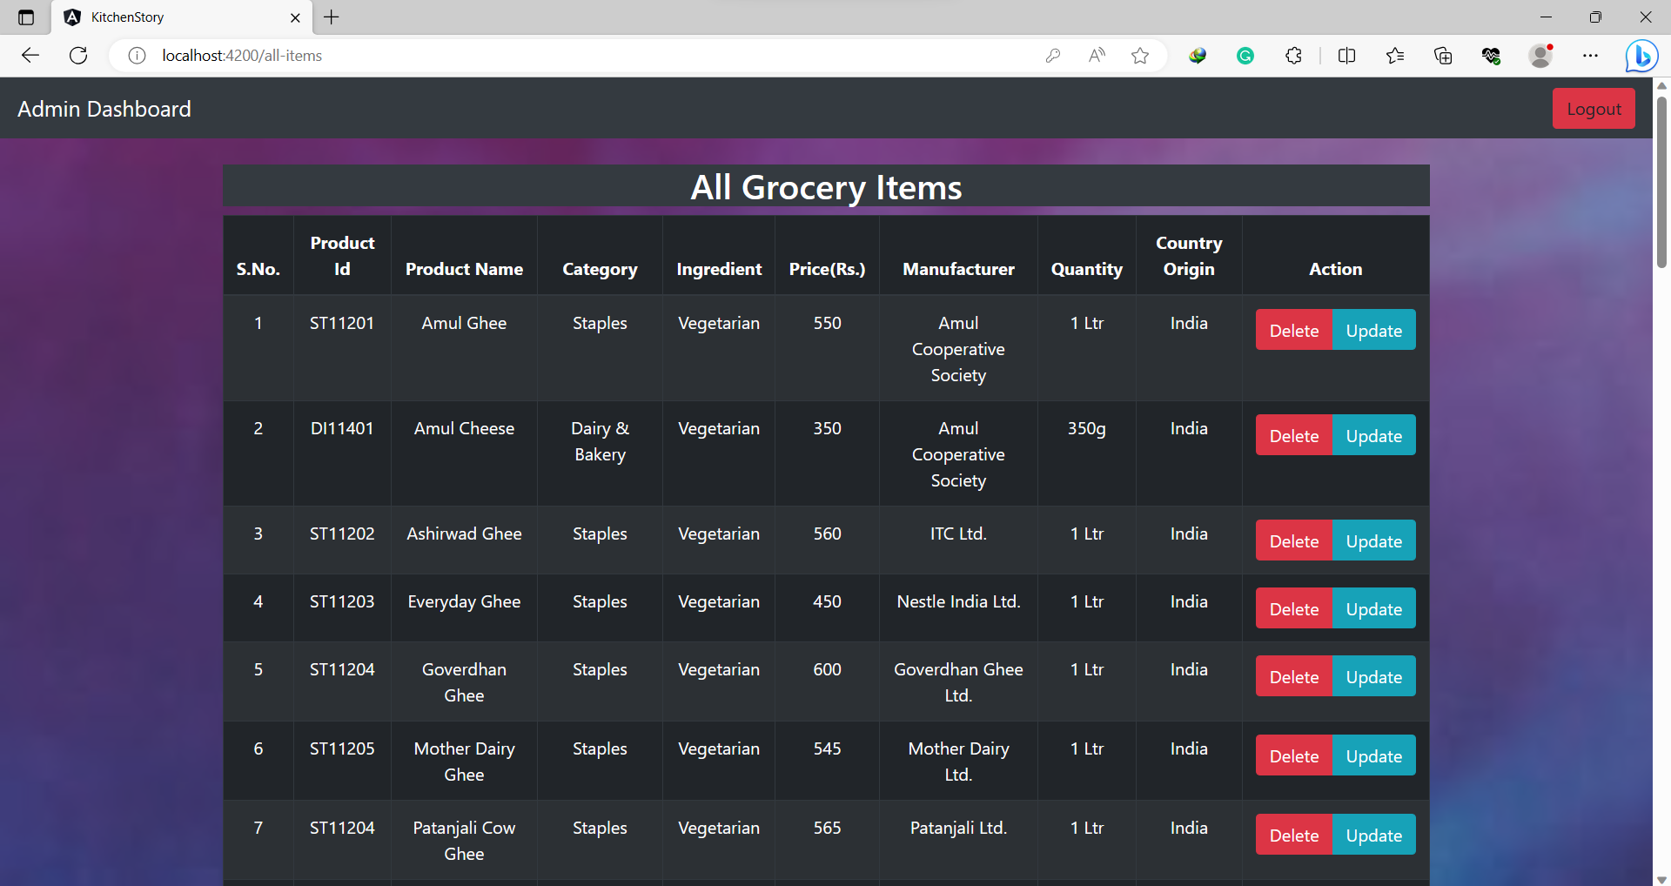

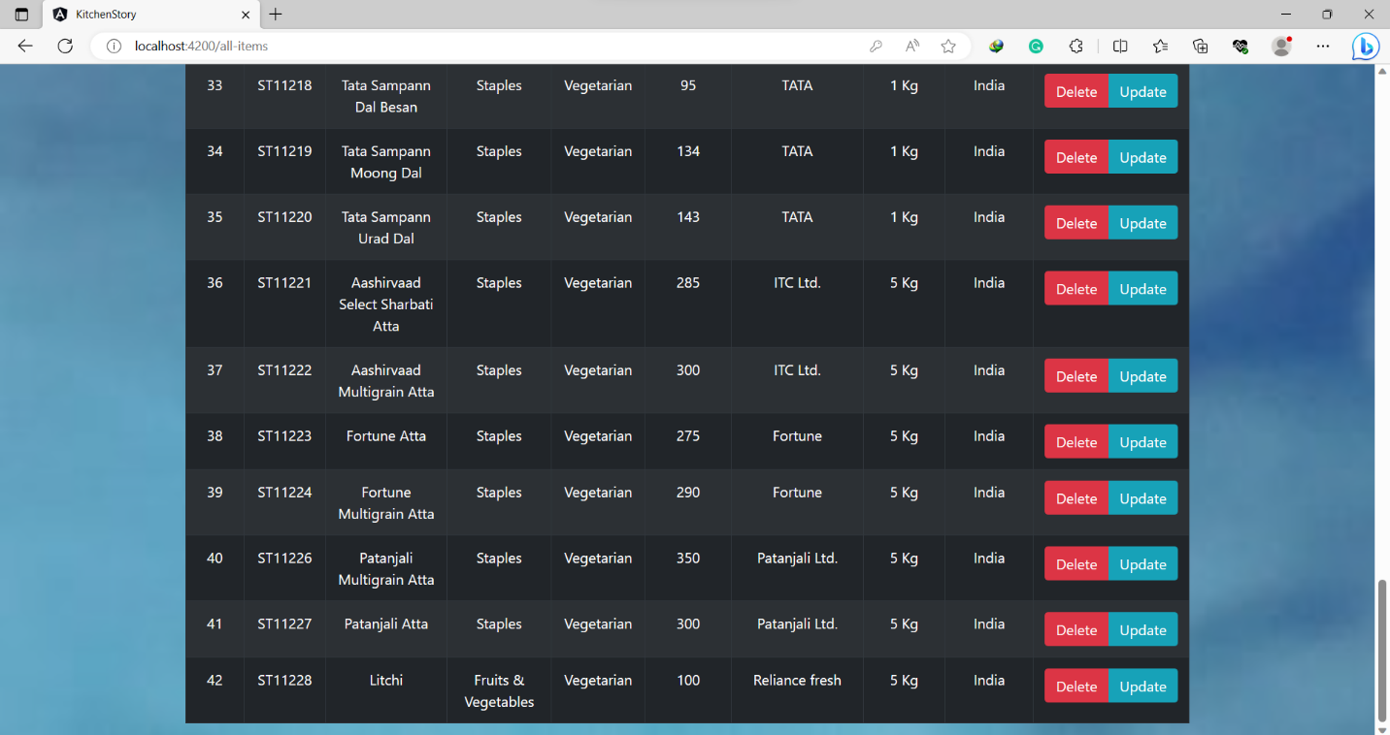

**If you want to update & delete any of item, then choose the option given.**

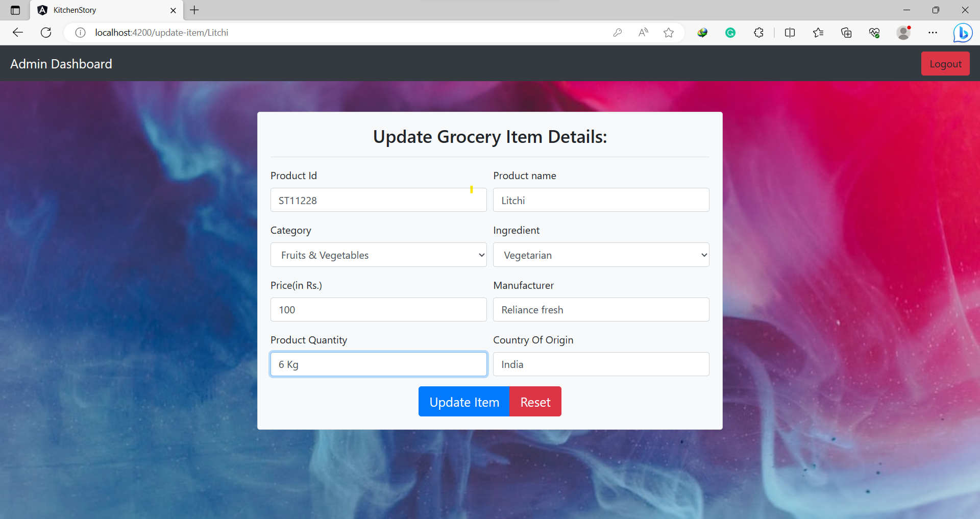**14. Update item Page**

**Then Back to Admin Dashboard & click on Show Orders option**

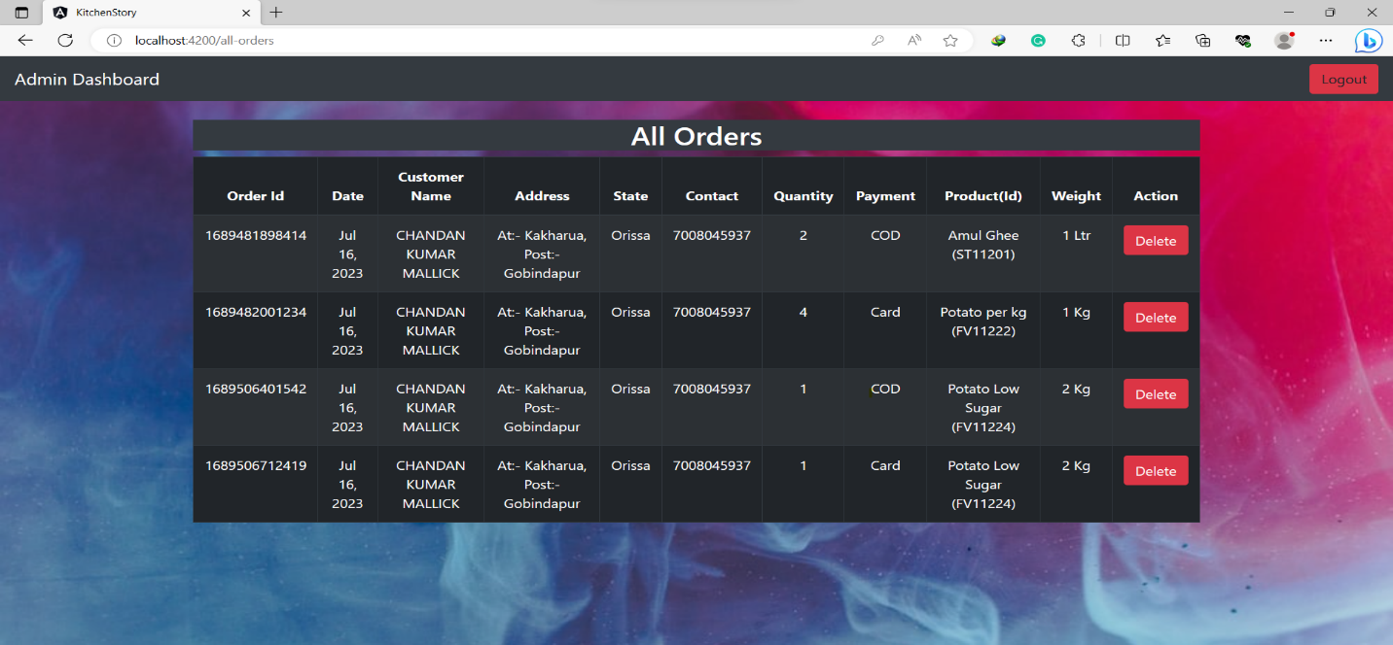**15. All Orders Page**

**==END==**